
CS 1010 Project4 – Run Python Run!

30 Points
Due: Monday - 11/12 @ 11:30

Propose:
In this project, you will write a complete Python program. This project will help you to practice while loops in a Python program.

Instructions:
- Follow these steps.
  - Create the ###lastnameproj4.py and ###lastnameproj4.docx on your desktop (use your class code for ### and your last name, copy the lab6 file with all that good code)
  - Launch Pyscripter and open the .py file from within Pyscripter.

- Add the banner documentation to reflect your new task and add your class code and name to the comments at the top as following:

You are an analyst for a sports information organization who has been given a file of names, racing times and ages for participants in a 1-mile race. Your task is to determine results for participants in various age categories (under 30, 30 to 50, and over 50) who qualify for the next race.

Here is example input data. (also see the runners.txt file) Robin
305
32

Opened the file "runners.txt" and use a while loop to process the data. The will keep track of the number of runners that qualify for each category, the average time for the runners that qualify for each category and the favorite (fastest person’s name, time and age) for the next race for each category. You will also keep track of the number of runners that did not qualify.
To determine if a runner qualifies for the next race use the following criteria:

under 30 needs to run 300 seconds or less
30-50 needs to run 360 seconds or less
over 50 must run 420 seconds or less

Note: a person age 29, running a time of 315 should not qualify (this is the tricky one)

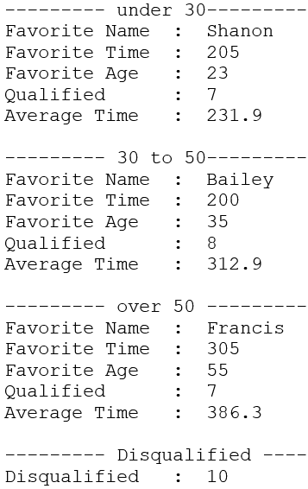
Your output: Please use the formatting given here:

Open the ###lastnameproj4.docx (with your class code) file and copy your output into the file using the snipping tool.

Grade Sheet

CS1010 Project 4: Run Python Run

Name ______________________________________

Project turned in and Coding standards:

(4) Python file and output files named correctly and turned in correctly (your own class code and last name)

(5) In-line comments complete (for each section)

- The above items are not a part of the 30 points but will be deducted if not implemented

Coding:

(5) Initialize counters and winners correctly

(5) Read data from the file correctly

(4) Under 30 results

(4) 30 to 50 results

(4) over 50 results

(4) Disqualified Results

(4) Output formatted correctly (lines, decimals, spacing)

(30 maximum) Total Points

